CLOUD COMPUTING
LAB 07



Submitted To:
Engr. Shoaib

Submitted By:
Komal Kashif BSE V-A
2023-BSE-031

Task 1 — Print & filter environment variables 1. Print all environment variables:
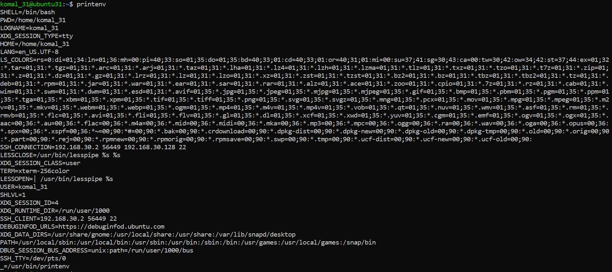
2. Filter for SHELL, HOME and USER — run these greps together and capture one combined screenshot:
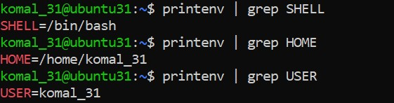

Task 2 — Export DB_* variables temporarily and observe scope
- Define all DB_* variables export DB_URL="postgres://db.example.local:5432/mydb" export DB_USER="labuser" export DB_PASSWORD="labpass123"
- Echo the three variables echo "$DB_URL"
echo "$DB_USER" echo "$DB_PASSWORD"
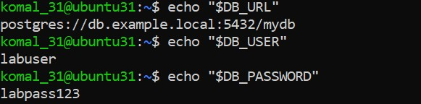
- Show all DB_ variables with a single grep command
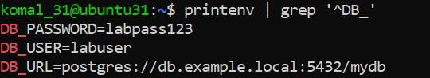
- Close the bash session (e.g., exit) and reopen a new terminal. Verify the variables are gone by running the echo(s) and the grep together
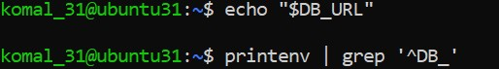

Task 3 — Make DB_* variables persistent in ~/.bashrc
- Open ~/.bashrc in an editor and append the three export lines:
export DB_URL="postgres://db.example.local:5432/mydb" export DB_USER="labuser" export DB_PASSWORD="labpass123"
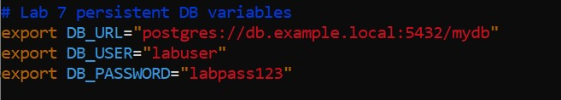
- Source ~/.bashrc and capture the source command in one screenshot together with the next verification commands (grouped): run source ~/.bashrc and then immediately run the three echoes and a single grep, capturing all of these in one screenshot:
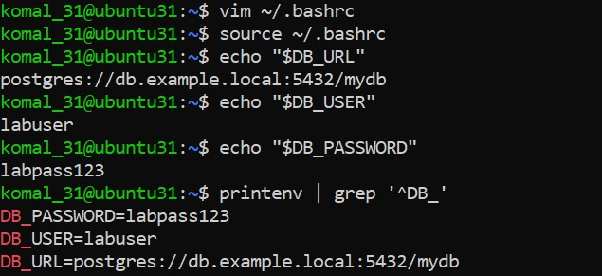

- Close and reopen terminal. Verify persistence by running one echo and the grep together:
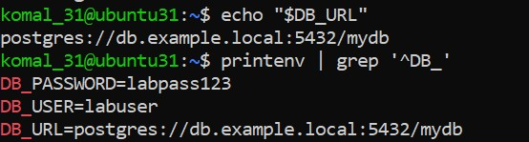

Task 4 — System-wide environment variable, welcome script, and PATH 1. View /etc/environment:
- Show current PATH:
- Edit /etc/environment and add Class:
# add line: Class="CC-<your_class_name>"
- Re-login or open a new shell and show Class and PATH together (grouped prints): run echo $Class and echo $PATH
- Create welcome script at your home directory (~/welcome) and make it executable cat > ~/welcome <<'EOF'
#!/bin/bash echo "Welcome to Cloud Computing $USER"
EOF
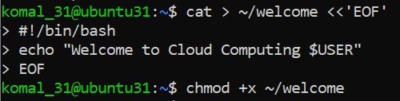
- Run the script from your home directory using ./welcome:
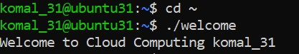
- Add your home directory to PATH in ~/.bashrc.
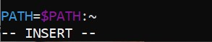
- Apply the change and run welcome
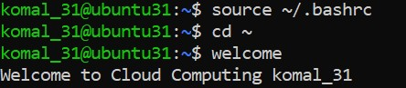

Task 5 — Block and allow SSH using ufw (firewall)
- Enable ufw and show status
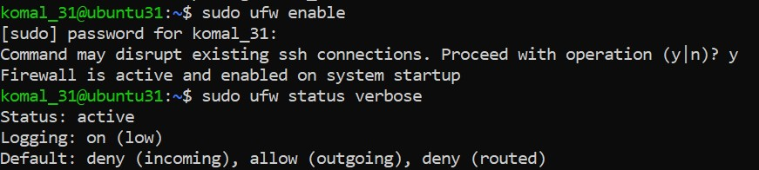
- Deny TCP port 22 and show status
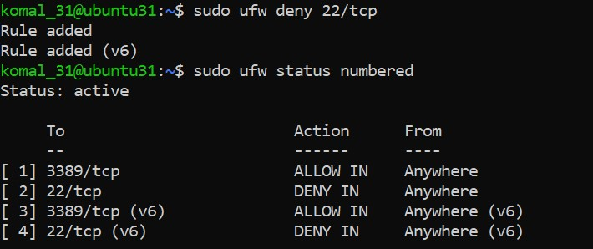
- From Windows host attempt to SSH (expected to fail)
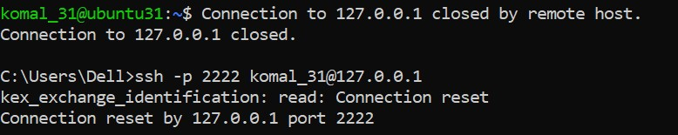

- Allow SSH back and reload, then show status (group allow, reload, status in one screenshot if run together).
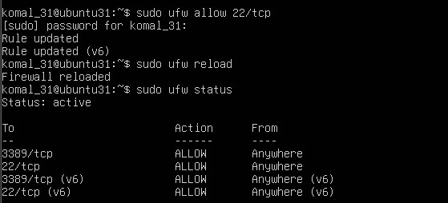

- From Windows host attempt SSH again (should succeed)
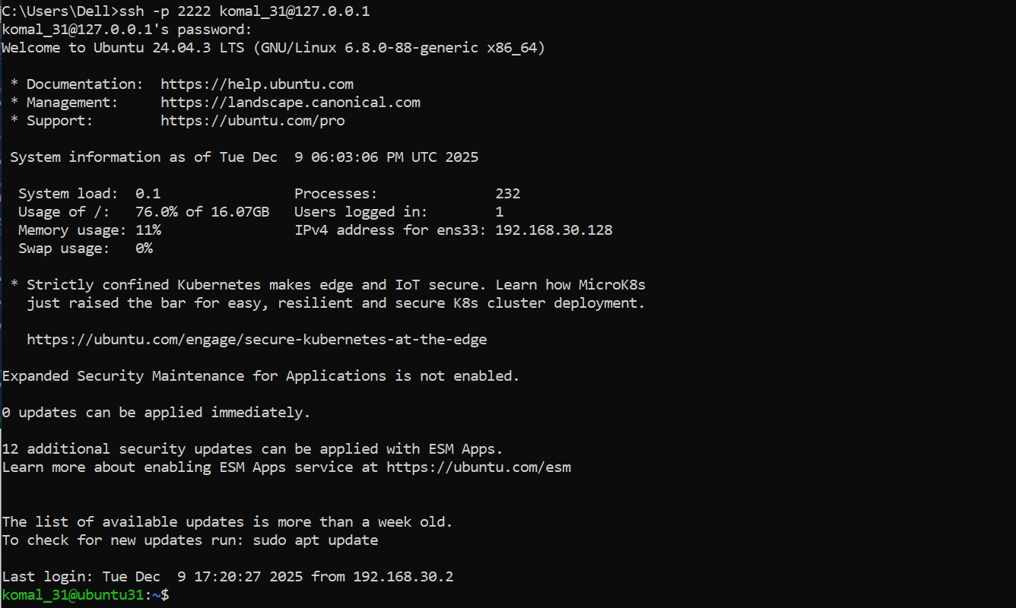

Task 6 — Configure SSH key-based login from Windows host
- On Windows host (client) — group related client actions:
  - Generate ed25519 key pair (if needed) and show the generated files in one screenshot (run ssh-keygen and then list ~/.ssh):
ssh-keygen -t ed25519 -f ~/.ssh/id_lab7 -C "lab_key"
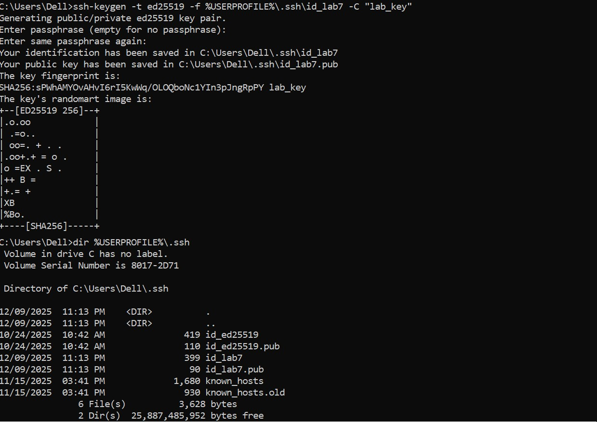
  - Show the public key content
  - Clear the known_hosts file content and verify it is empty:
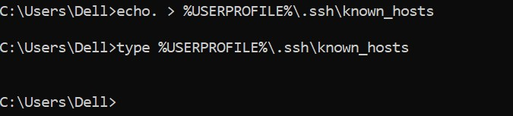

  - Connect to the Ubuntu server using the standard SSH command (this will prompt to accept the server host key because known_hosts is empty).
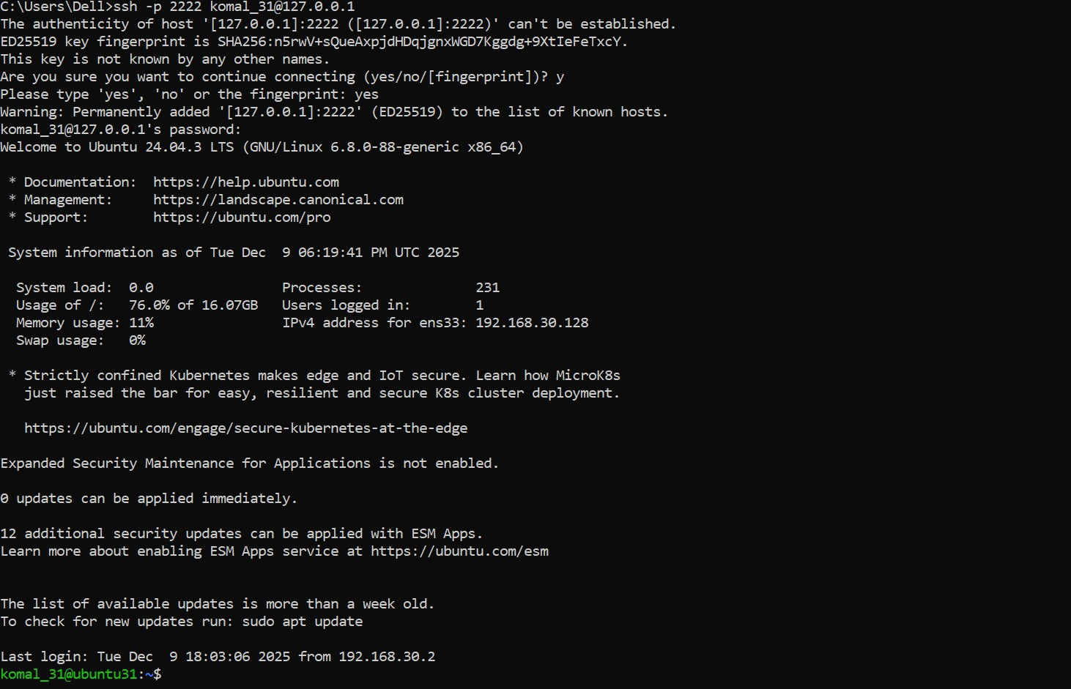
  - After the successful connection, view the known_hosts file to show the server host key was added
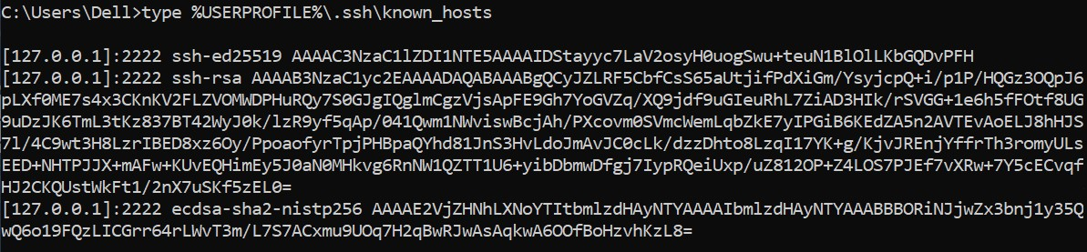

- On Ubuntu server — group related server-side commands:
  - Prepare the ~/.ssh directory and clear authorized_keys (this will create the directory if missing, set the correct directory permissions, and truncate the authorized_keys file).
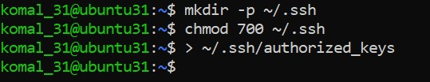

  - Append the public key, set file permissions, and show the resulting authorized_keys
  - From Windows host test password less login:
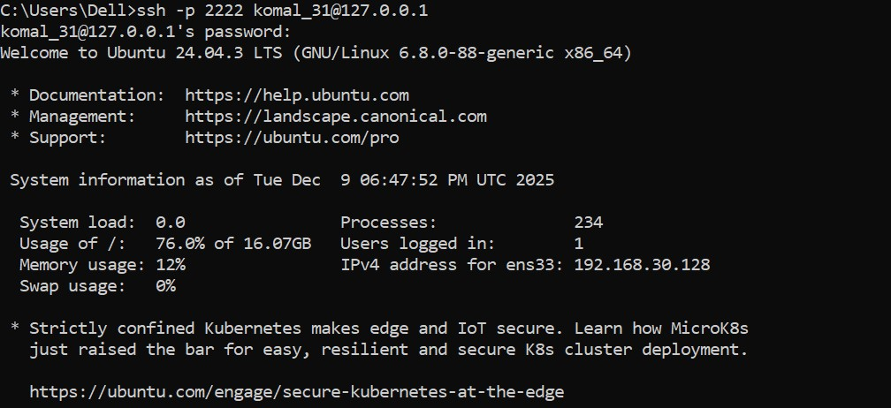
  - Also demonstrate explicit identity usage
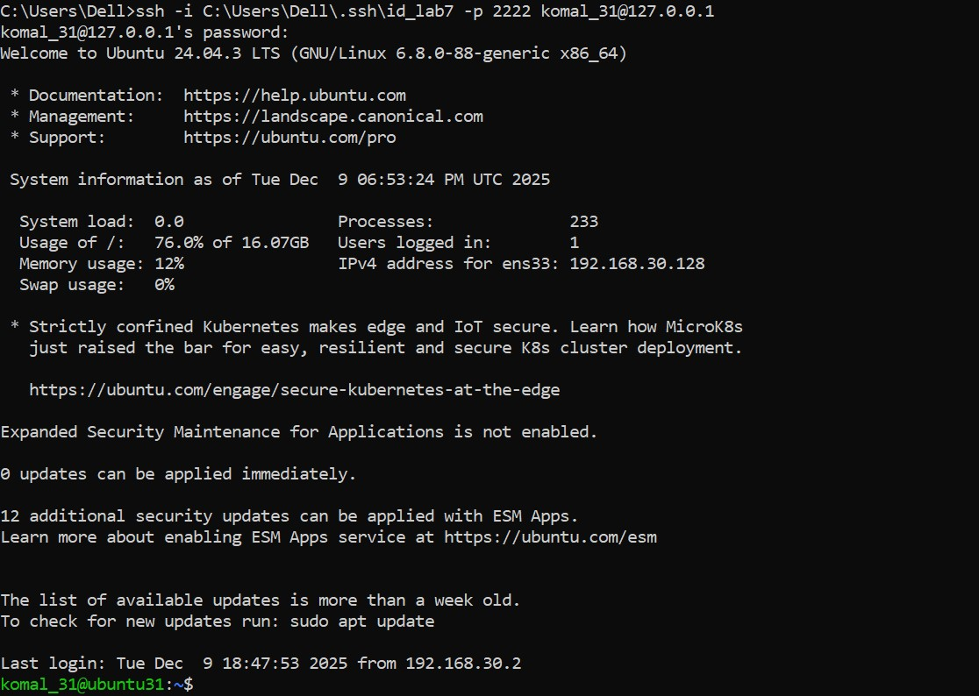

Exam Evaluation Questions
Q1: Quick Environment Audit
  - Objective: Demonstrate you can inspect the current environment and extract a few key variables.
  - Actions & evidence:
    - Run a single command to display environment variables and capture its output.
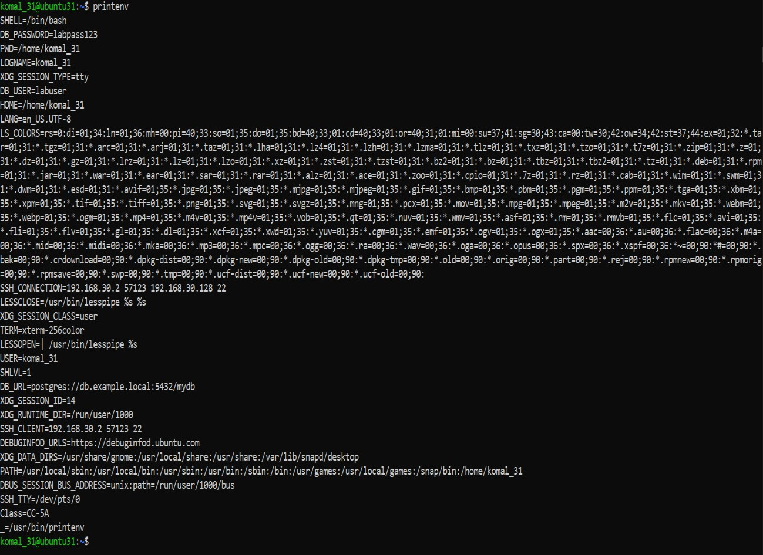
    - In the same terminal session, run three filters (one per line) to show values for PATH, LANG, and PWD
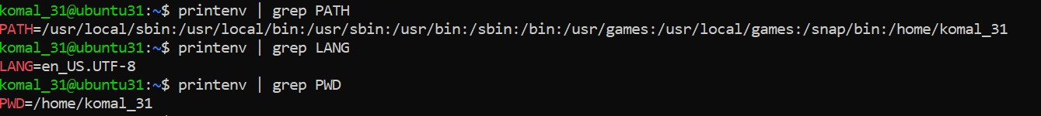
Q2: Short-lived Student Info
  - Objective: Show how temporary environment variables behave (session-scoped).
  - Actions & evidence:
    - In one terminal, set three variables (STUDENT_NAME, STUDENT_ROLL_NUMBER, STUDENT_SEMESTER) using export
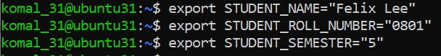
    - Still in the same session, print the three values with echo (grouped)
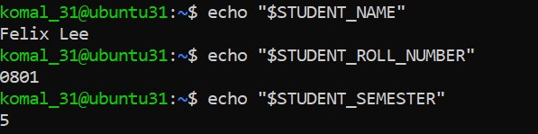
    - Use a single printenv|grep command to list any STUDENT_ variables and capture the result.
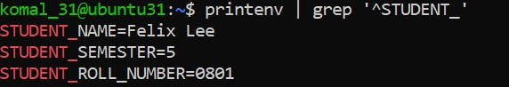
    - Exit that shell, open a fresh terminal, and show that the STUDENT_ variables are not set (use echo and printenv|grep together)
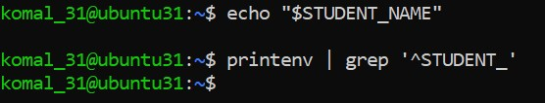

Q3: Make It Sticky (Persistence Check for Student Info)
  - Objective: Demonstrate persistence of environment variables across sessions via shell configuration.
  - Actions & evidence:
    - Edit ~/.bashrc and append the three STUDENT_* exports.
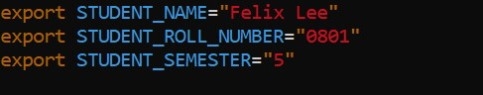
    - Reload your shell config with a single command and then verify the three variables and show printenv | grep '^STUDENT_'
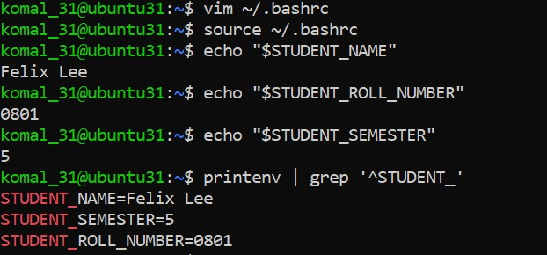
    - Close and re-open a terminal and demonstrate the STUDENT_NAME variable is available (echo and printenv grep together)
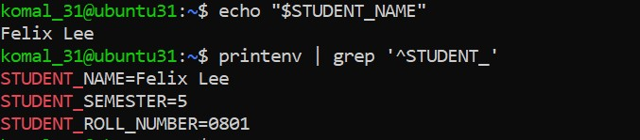

Q4: Firewall Rules: Block and Restore Ping (ICMP)
  - Objective: Demonstrate you can block ping (ICMP echo) traffic using ufw and then re-allow it; show effect from a client.
  - Actions & evidence:
  - Enable ufw
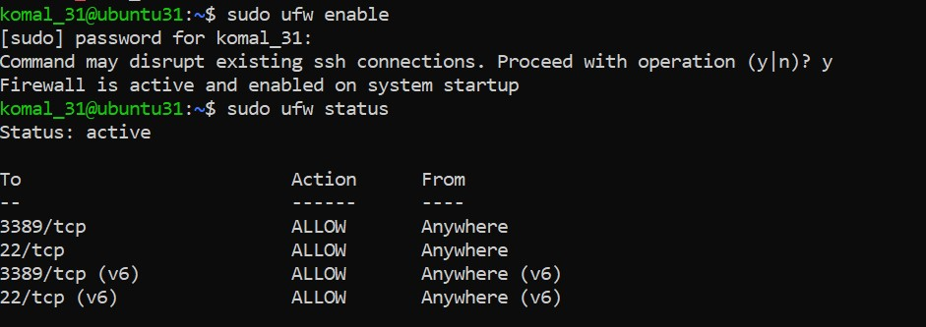
  - Add a rule to block ping (ICMP echo) and show ufw status numbered
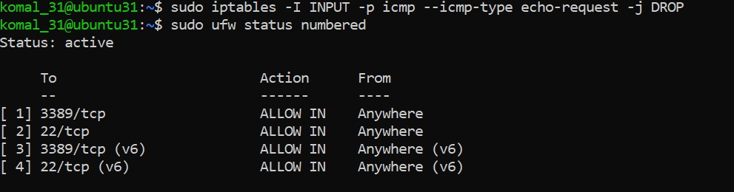
  - From your Windows host (or another client), attempt to ping the server while the rule is active and capture the blocked/failing ping
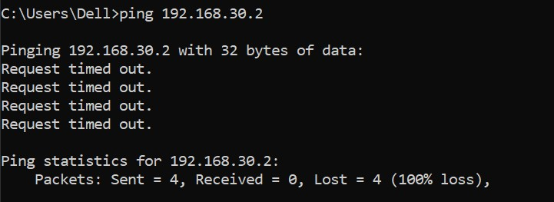
  - Re-allow ping (ICMP) (or remove the deny rule)
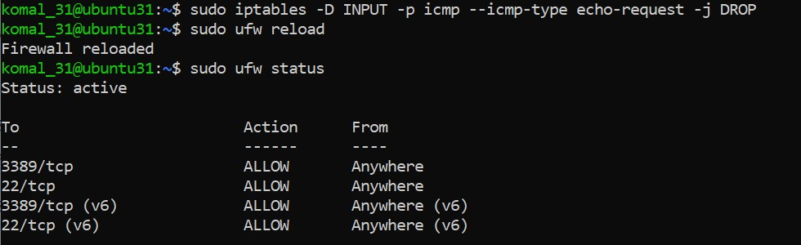
  - From the client, ping the server again
